- Passport photo | 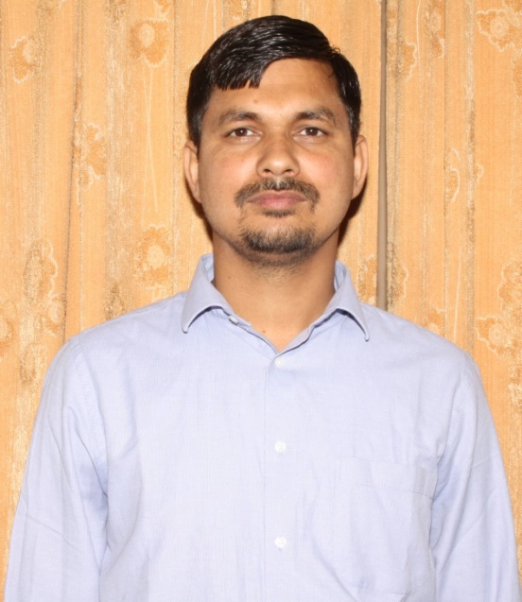
- Name: | Dr. Manoj Kumar Riyal
- Subject: | Physics
- Mobile No.: | 9411527950
- E-mail ID: | manoj.riyal@gmail.com
- Orcid ID: | 0000-0003-0318-6341

Faculty Profile:

Dr. Manoj Kumar Riyal is an Assistant Professor of Physics with about 15 years of teaching and research experience at the undergraduate and postgraduate levels. He holds an M.Sc. and Ph.D. in Physics from H.N.B. Garhwal University, Srinagar Garhwal, and is CSIR-NET qualified in Physical Sciences. His academic and research interests span Theoretical Physics, Acoustics, Soundscape, Statistical Ecology, Mathematical Modelling, Data Science, and Artificial Intelligence, with interdisciplinary applications in Environmental Science, Forestry, and biological sciences.
- Dr. Riyal has more than 40 research papers in Scopus-indexed journals, along with books, book chapters, and conference contributions.
- He has undertaken professional training at institutions including IIT Guwahati, TIFR Mumbai, IASRI, IISc Bengaluru, and ICAR-NAARM, covering Automatic Speech Recognition, speech analysis, experimental design, survey-data analysis, nanofabrication technologies, and Artificial Intelligence in Agriculture.
- He has completed several online courses from internationally recognised universities, including Johns Hopkins University, Arizona State University, Duke University, Stanford University, and Dartmouth College, strengthening his expertise in statistics, experimental design, data science, environmental science, and artificial intelligence.
- He is a Life Member of the Acoustical Society of India, Indian Association of Physics Teachers, and Society for Technological Advanced Materials, India.
- He has contributed to academic administration through admission coordination, Boards of Studies, Faculty Development and Induction Programmes, examinations, and other academic and student-related activities.

